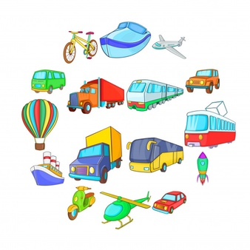

Music

We will be learning to sing lots of songs about transport and create our own ‘On the Move’ music.

Wow! – trip to

Motor museum

Geography

As we travel around the world we will be looking at the seven continents and the oceans. We will study atlases and maps to learn about the geographical and human features of countries and compare a place here and abroad.

Science

We will be studying materials and their properties linked to different modes of transport. We will also look at how different things move on different surfaces. Coinciding with our work on the book ‘Lost and Found’ we will be making our own boats and investigating the concept of floating and sinking and the materials which are best suited to making a boat. As we travel around the world we will also be observing the weather and the changes of the seasons.

History

We will learn about how transport has changed over time and create our own timelines. We will also research famous people who have taken voyages across the globe.

On the move!

Year 1 and 2

Art/DT

Based on the book by Patricia Cleveland-Peck, we will be designing and making different modes of transport to accommodate a variety of animals! We will investigate the mechanisms used to enable them to move.

PE

We will be learning dance movements where the children will be able to perform basic movements to music to build a simple transport themed dance.

English

We will look at a range of fiction books related to being on the move including:

* Journey by Aaron Becker
* The Train Ride by June Crebbin
* You can’t take an elephant on the bus by Patricia Cleveland-Peck
* Lost and Found by Oliver Jeffers

Using these books we will be writing our own stories and descriptions and travel with the characters on their journeys around the world. We will also be looking at poetry, specifically about bicycles, and then writing our own.

Maths

We will make links with measuring length, weight and capacity when looking at different modes of transport. We will also be looking at position and direction and compass points to create routes and journeys. We will also be solving a range of puzzles and problems.