|  |  |  |  |  |
| --- | --- | --- | --- | --- |
| C:\Users\Mary\AppData\Local\Microsoft\Windows\Temporary Internet Files\Content.IE5\ND9RU5M8\MC900365776[1].wmf | C:\Users\Mary\AppData\Local\Microsoft\Windows\Temporary Internet Files\Content.IE5\ND9RU5M8\MC900358879[1].wmf | C:\Users\Mary\AppData\Local\Microsoft\Windows\Temporary Internet Files\Content.IE5\DKQVQZ0I\MC900233681[1].wmf | C:\Users\Mary\AppData\Local\Microsoft\Windows\Temporary Internet Files\Content.IE5\KZJOT6VC\MC900445736[1].wmf | C:\Users\Mary\AppData\Local\Microsoft\Windows\Temporary Internet Files\Content.IE5\RZTAIF8C\MC900232101[1].wmf |

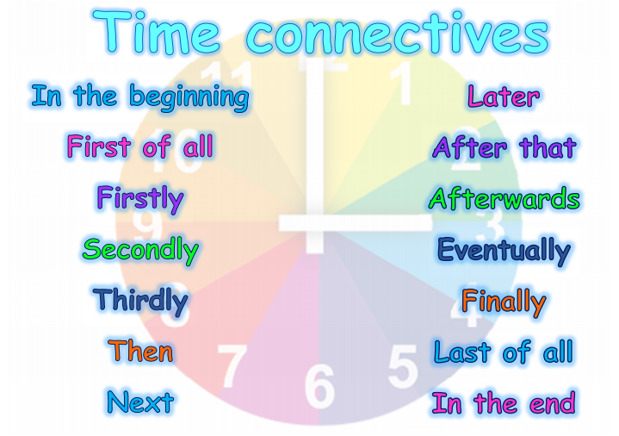

Can you put the pictures of the day in the correct order and then write a sentence for each starting with a time connective. You could use some of the ideas on this sheet to start your sentences.

Eg First of all I wake up in the morning.

Year 2, you could write some longer sentences using the conjunctions and, but, or, so, when, because or if to give some extra detail. You could even add in some pictures of your own.

Eg First of all I wake up in the morning **and** I turn on my bed side light.

Make sure that you use capital letters and full stops please.