Two-digit Targets
You have a set of the digits from 0 - 9.
Can you arrange these digits in the five boxes below to make two-digit numbers as close to the targets as possible? You may use each digit once only.
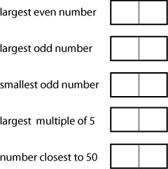
Hint - Make yourself a set of number cards to move around.

Key questions
What have you tried so far?
What do you know about odd numbers/even numbers/multiples of 5? How does this help you place the digits?
Can you create a 'better' solution? How will you know it is better?

